# Retirement Finance Simulation Model

# Client: Farrar

Mon Jan 29 14:01:56 2018

# Section 1. Simulation Parameters

The first section of this report identifies the parameters used for the simulation.

NOTE THAT ALL RESULTS AND INPUT PARAMETERS ARE EXPRESSED IN REAL (TODAY'S) DOLLARS. Assets with no inflation protection will show a decline in value over time based on simulated inflation rates.

Parameters for the simulations are as follows:

* Run 10,000 scenarios.
* Demographic data
  + Husband's current age is 63.
  + Wife's current age is 62.

Note: Your Excel file had you both claiming at 70 but you will find better results if the higher earner claims at 70 and the lower earner claims at Full Retirement Age.

* Social Security data
  + Husband claims at age 70
  + Wife claims at age 66.
  + All claiming options:

|  |  |  |
| --- | --- | --- |
|  | higherEarner | lowerEarner |
| Age62 | 25392 | 8316 |
| FRA | 30648 | 11676 |
| Age70 | 41556 | 15672 |
|  |  |  |

* Portfolio parameters
  + Initial portfolio balance before annuity purchase is $ 1,020,000.
  + Equity allocations randomized from 0% to 100%.
* Market and inflation parameters
  + Annual average rate of inflation is 2%.
  + Inflation rate annual standard deviation is 1%.
  + Risk-free real return rate is 1%.
  + Equity risk premium is 4.25%.
  + Standard deviation of annual market returns is 12%.
* Immediate Annuity (SPIA) parameters
  + SPIA Purchase age is 62
  + Age of annuitant when payments will begin is 62.
  + Annuity is inflation-protected is TRUE.
  + Husband owns Annuity is FALSE.
  + Percent of benefit that goes to survivor is 50%.
  + SPIA payout rate is 5.36%.
  + SPIA allocation as percent of initial portfolio randomized from 0% to 0% in 10% increments.
* Deferred Income Annuity (DIA) parameters
  + DIA Purchase age is 63
  + Age of annuitant when payments will begin is 0.
  + Annuity is inflation-protected is FALSE.
  + Husband owns Annuity is FALSE.
  + Percent of benefit that goes to survivor is 0%.
  + DIA payout rate is 0%.
  + DIA allocation as percent of initial portfolio randomized from 0% to 0% in 10% increments.
* Spending parameters
  + Expected spending year one of retirement randomized from $ 63,000 to $84,000.
  + Percent expense decline after death of first spouse is 66.67%.
  + Expenses typically decline 0% annually throughout retirement.
* HECM Line of Credit Your HECM doesn’t impact this simulation.
  + Home apprecation rate is 0% annually.
  + Initial HECM Line of Credit available is $ 0
  + Initial Reverse Mortgage Balance is $ 76,433
  + Home Market Value (no real annual growth assumed) is $ 250,000
  + Mean long term return for 1-yr Libor= 2% with standard deviation= 1%
  + HECM line of credit's maximum lifetime interest rate cap 0%
  + HECM line of credit's margin added to Libor Index for variable rate loan 0%
  + HECM line of credit's Monthly Insurance Premium percentage 0%

# Section 2. Graphs of Simulation Parameters

Section 2 of this report graphically displays key simulation input parameters.

Life expectancies for husband and wife are plotted below.

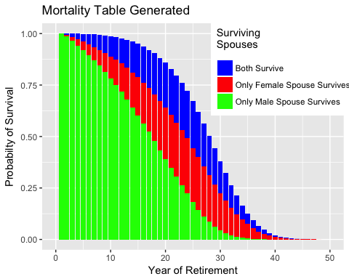

The following annual market returns were simulated.

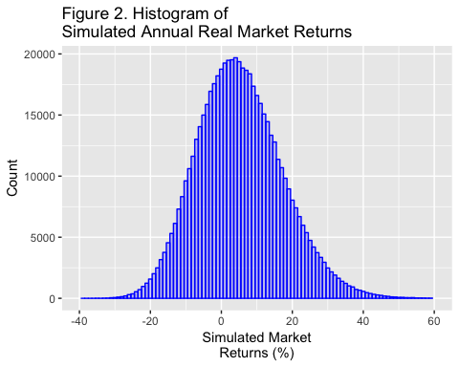

Arithmetic Mean of Simulated Annual Returns = 5.262%.

Standard Deviation of Simulated Annual Returns = 12.014%.

The following simulated annual inflation rates were simulated:

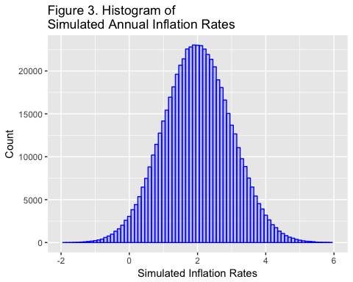

* Arithmetic Mean of Simulated Inflation Rates = 2.001%.
* Standard Deviation of Simulated Annual Inflation Rates = 0.999%.

The following graph shows the number of scenarios that were simulated at various first-year spending rates. The x-axis also displays the range of first-year spending that was simulated.

The minimum first-year spending simulated was $ 63,000.

The maximum first-year spending simulated was $ 84,000.

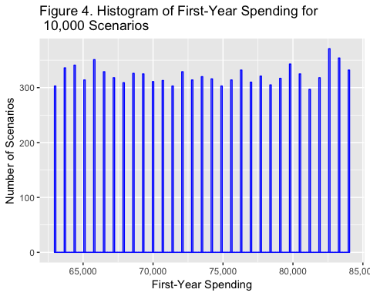

The graphs that follow are intended to show the range of inputs used by the simulation model (for example, the range of spending tested) and the distributions of the input parameters (for example, life expectancy follows a Gompertz distribution, while spending parameters are randomized with a uniform distribution.)

The following chart shows the number of scenarios simulated at each level of annuity (SPIA) allocation as a percent of initial portfolio value. The *x*-axis shows the range of SPIA allocations simulated.

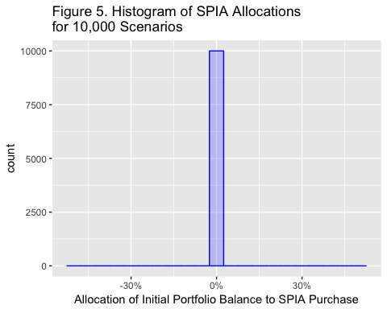

No SPIAs simulated.

The following chart shows the number of scenarios simulated at each level of deferred income annuity (DIA) allocation as a percent of initial portfolio value. The *x*-axis shows the range of DIA allocations simulated.

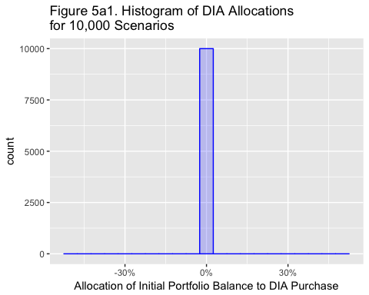

No DIAs simulated.

The following chart shows the number of scenarios simulated at each level of equity allocation. The *x*-axis shows the range of equity allocations simulated.

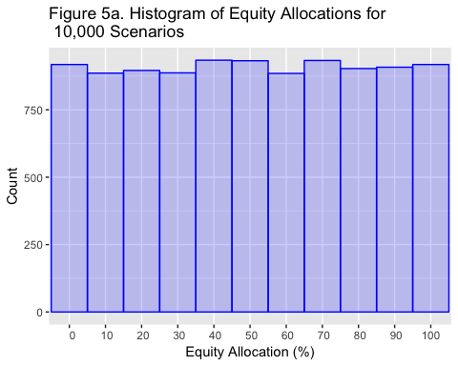

# Section 3. Results of Simulations

Section 3 provides the results of the simulation.

## Statistics For Underfunded Scenarios

* 1 scenarios with unmet spending or 0.01%
* Some failed scenarios were almost completely funded, while some funded scenarios were just barely funded. These scenarios fall within the margin of error.
* Percent of scenarios that funded less than 95% of years 0.01%
* Number of years with unmet spending 7
* Mean years with unmet spending when spending not met 7
* Depleted portfolios 0.01 %
* Scenarios depleting HECM Line of Credit 0 or 0%

Very low failure rates with your current finances. HOWEVER. . . this tells you only the probability of a bad outcome, not what happens in the low probability of a catastrophe. That’s determined by your floor.

Following is a histogram showing spending amounts (and the range of spending along the *x*- axis) for the first year of each retirement scenario.

This histogram shows the cumulative ratio of underfunded simulated scenarios by the amount of spending for the first year of retirement. The right-most column, for example, shows that 100% of 1 unfunded scenarios had spending in the first year of retirement of $ 81,900 or less. The column to its left shows that about 80% of all 1 unfunded scenarios had spending in the first year of retirement of $ 81,900 or less.

About half of the 1 underfunded scenarios in this simulation could have been funded by spending less than $ 81,900 from the beginning of retirement.

If an empty chart appears below, then there were no underfunded scenarios.

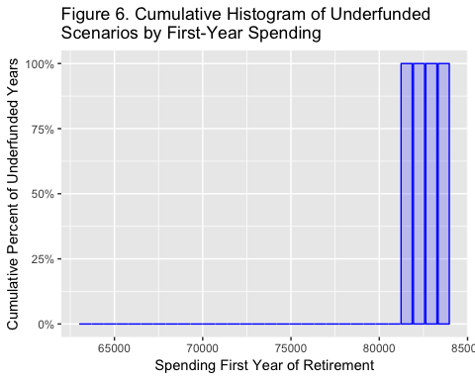

There are almost no failures at any of the spending levels.

Following is a cumulative histogram showing the equity allocation for 53 underfunded *scenarios*. If no chart appears below, then there were no underfunded years.

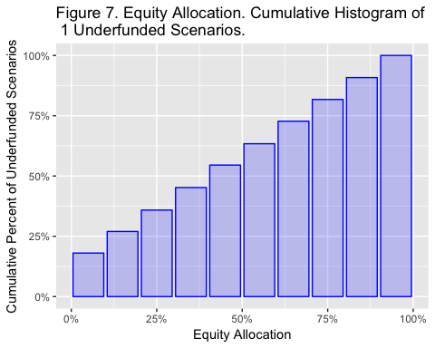

Not meaningful since there are almost no failures.

Following is a histogram showing the equity allocation for 53 underfunded *years*. If no chart appears below, then there were no underfunded years.

Following is a cumulative histogram of SPIA annuity allocations for the 1 scenarios with unmet spending.

No plot is generated when a single annuity allocation is selected, which is TRUE for this simulation.

Following is a cumulative histogram of DIA annuity allocations for the 1 scenarios with unmet spending.

No plot is generated when a single DIA allocation is selected, which is (TRUE) for this simulation.

Following is a histogram of 95th percentile terminal net worth (portfolio value plus home equity at death of the second spouse). The largest 5% of terminal net worth values are excluded because they are highly unlikely and distort the graph.

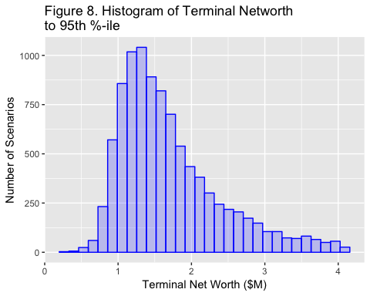

* Mean Terminal Net Worth = $ 1,908,764.
* 5% of Terminal Net Worth values fell below $ 911,475.
* 10% of Terminal Net Worth values fell below $ 1,007,126.
* 25% of Terminal Net Worth values fell below $ 1,221,146.
* 50% of Terminal Net Worth values (the median) fell below $ 1,563,169.

The median has more validity than the mean because the outcomes are left-skewed.

The following graph shows a histogram of terminal portfolio values (TPVs). The best 5% of TPVs are eliminated for this graph because a) they are highly improbable, b) they distort the graph and c) if they did occur, they would be excellent outcomes and not a downside risk.

The median has more validity than the mean because the outcomes are left-skewed.

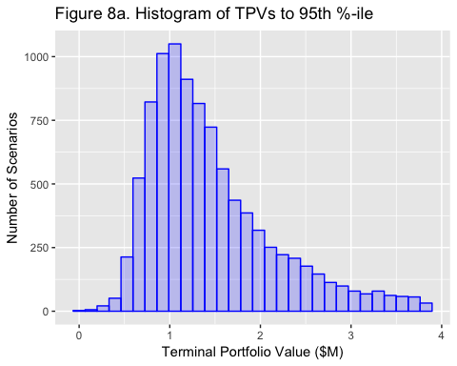

* Mean Terminal Portfolio = $ 1,658,764.
* 5% of Terminal Portfolio values fell below $ 661,475.
* 10% of Terminal Portfolio values fell below $ 757,126.
* 25% of Terminal Portfolio values fell below $ 971,146.
* 50% of Terminal Portfolio values (the median) fell below $ 1,313,169.

The chart above shows the ten portfolio balance paths with the highest TPV, the ten paths with the earliest portfolio depletion and the path with the median Terminal Portfolio Value.

The best paths are highly improbable and not critical in the sense that if your portfolio did take one of those paths the outcomes would be wonderful. The worst paths are also highly improbable but should be given more consideration because, while best path outcomes would be wonderful, worst path outcomes would destroy the retirement plan. A good plan will eliminate these worst-case outcomes.

Though this graph shows 21 paths, the simulation actually generated 10000 hypothetical paths. Also note that the graph lines end when the last spouse dies.

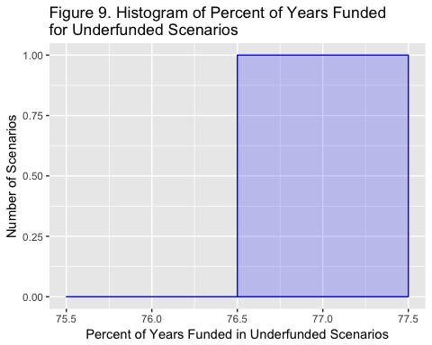

The graph above shows the 53 years of retirement for which spending demand (consumption) was not met. If an empty chart appears above, then there were no underfunded years.

The rightmost columns represent scenarios that were *mostly* funded. Leftmost columns represent scenarios that were *least* funded.

The following chart shows terminal home equity for all scenarios. If a HECM reverse mortgage is available, home equity can become negative but this is non-recourse debt and will not lower the household's terminal net worth.

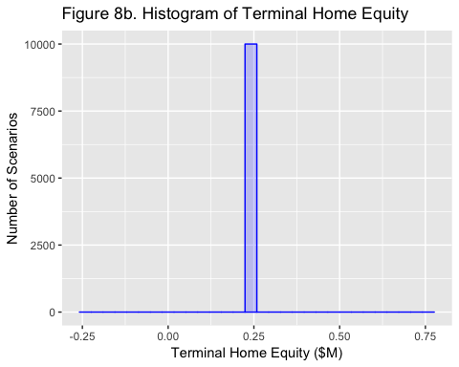

The following chart shows which equity allocations produced the 1 underfunded scenarios.

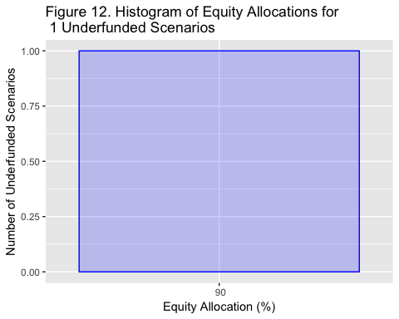

The following chart shows safe (longevity-hedged) income (the "floor") by year of retirement. The dark line shows the mean safe floor income for all scenarios for each year of retirement, while the shaded area shows the range from the smallest floor income for any scenario for that year of retirement to the largest floor income for any scenario for that year of retirement. The black line shows mean annual expenses across all scenarios.

The floor does not include income from TIPS bond ladders because longevity risk is not hedged (you can outlive a ladder). HECM income is not included in the floor because it is contingent upon the continued ownership of your hopme and not on your lifetime.

Note that annuities and pensions that are not inflation-protected will lose value to inflation each year, as simulation results are all calculated in real dollars.

Also note that for retired *couples*, the upper bound of floor income may decline sharply at the end of retirement. The upper bound of the pink area equals the maximum floor value of all scenarios at a given age. At some time, those scenarios will no longer include the probability that both spouses survive. When only one spouse survives, Social Security benefits may decline significantly and the maximum benefit for all scenarios at that age will aslo decline.

For example, assume that in year 42, there are many scenarios in which the wife survives but only two scenarios in which the husband survives. Nonetheless, the maximum floor value for year 42 would be determined by the presence of those two scenarios. Assume further that in year 43, there are no simulated scenarios in which both spouses survive. The maximum floor value would then be determined only by the wife's benefit.

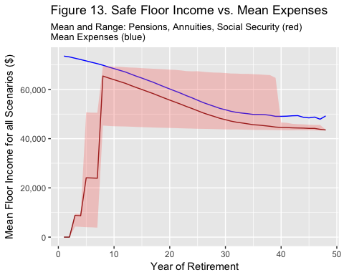

The last two charts of this report provide details for a single randomly-selected scenario, scenario number

The following chart shows cash flow for scenatrio number 2. The black line shows consumption demanded. The colored areas indicate the source for funding that consumption.

Underfunded years will show that funding sources did not achieve demanded consumption -- the colored bars will not reach the black dots. When the colored bars exceed the black dots expenses for that year were exceeded by the safe floor income even without portfolio spending. The excess above the black dot is transferred to the savings portfolio.

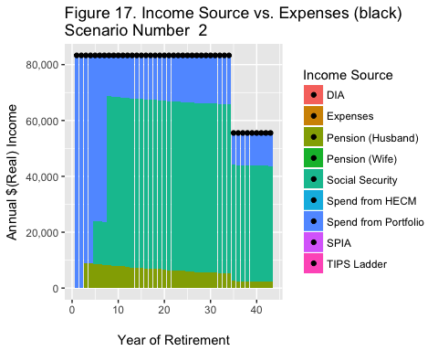

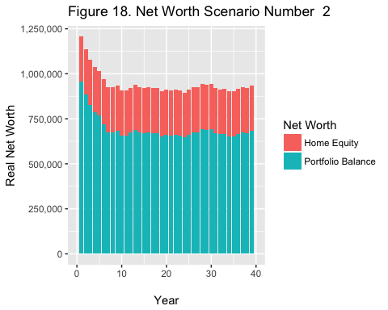

Summary of Floor income with 20% Annuitization

Summary floor income before inflation and after all pensions and Social Security payments begin with a 20% annuity allocation.

|  |  |  |  |
| --- | --- | --- | --- |
|  | Both Survive | Husband Survives | Wife Survives |
| Social Security Benefits | 53232 | 41556 | 41556 |
| Wife's Pension | 0 | 0 | 0 |
| Wife's Pension (survivor) | 0 | 0 | 0 |
| Husband's Pension | 9300 | 9300 | 0 |
| Husband's Pension (survivor) | 0 | 0 | 4650 |
| SPIA Income | 0 | 0 | 0 |
| DIA Income | 0 | 0 | 0 |
| TOTAL | 62532 | 50856 | 46206 |